 | Europejski Urząd Doboru Kadr (EPSO) i MSZ zapraszają do aplikowania!  EU Careers Student Ambassadors  If you are a student keen to promote EU careers on UW  then why not apply to become an EU Career Student Ambassador?

As part of the experience, you will be able to:  - Find out more about EU Career opportunities and promote them to your fellow students  - Build a fantastic student network across Europe  - Gain work experience during your studies that will give your CV extra weight  - Develop your skills in public speaking, marketing and HR  - Receive a full induction training and coaching throughout the role  - Access to high-ranking EU officials  - A reference letter based on your performance. | We are looking for motivated Ambassadors who want to promote the benefits of an EU Career and have the following competences:  - Excellent communication skills  - Networking skills  - Willingness to share and learn  - Ability to adapt  - Good organisational skills  - Ability to deliver quality and results  - Innovative and creative approach  - Resilience

What does an Ambassador do?  - Act as a point of contact for students interested in EU Careers  - Research target groups and contact university media  - Set up mailing lists and distribute information on EU Careers through the appropriate channels  - Give presentations, attend university careers events and find interesting speakers  - Complete monthly tasks and regularly report back on your activities  - Manage and regularly monitor a dedicated Facebook page / online presence | The EU Careers Ambassadors scheme involves finding innovative ways of promoting the great opportunities the EU institutions have to offer, including through:  - attending careers fairs, or giving presentations to your fellow students  - developing university networks and providing information  - maintaining an active online and social media presence  - answering questions about EU Careers

Offer info:  - Commit at least two hours per week to your Ambassador role  - Arrange or participate in a minimum of one EU Careers event or presentation  - Communicate on a regular basis with your EU Careers coordinator  - Participate in all training offered (online)  - Keep a log of your activities and report back regularly | You must be:  • Available to take part in our compulsory training course in October 2019  • Enrolled and present at the university for the duration of the Ambassador's post (October 2019 - September 2020)  • An EU citizen  • Fluent in of the language of the country you are studying in  • Able to communicate in English language (all correspondence with EPSO will be in English)

Apply today! Send your CV to this email: biurokarier@adm.uw.edu.pl
Email subject: Ambasador Kariery EU"

Please include in your CV: „I hereby give consent for my personal data included in my application to be processed for the purposes of the recruitment process under the Personal Data Protection Act European Parliament as of 27 April 2016, consolidated text: Journal of Laws 2016, item 679 as amended.”

Please include in your email: „Wyrażam zgodę na przetwarzanie moich danych osobowych przez Biuro Zawodowej Promocji Studentów i Absolwentów UW dla potrzeb niezbędnych do realizacji procesu rekrutacji na stanowisko: "Ambasador EU Careers", zgodnie z art. 6 Rozporządzenia Parlamentu Europejskiego i Rady (UE) 2016/679 z dnia 27 kwietnia 2016 r. w sprawie ochrony osób fizycznych w związku z przetwarzaniem danych osobowych i w sprawie swobodnego przepływu takich danych oraz uchylenia dyrektywy 95/46/WE, w tym przekazanie mojego CV do podmiotu rekrutującego: Ministerstwa Spraw Zagranicznych” i Europejskiego Urzędu Doboru Kadr "EPSO".
„I hereby give consent for my personal data included in my application to be processed for the purposes of the recruitment process under the Personal Data Protection Act European Parliament as of 27 April 2016, consolidated text: Journal of Laws 2016, item 679 as amended.”

OFERTĘ POLECA UWADZE | 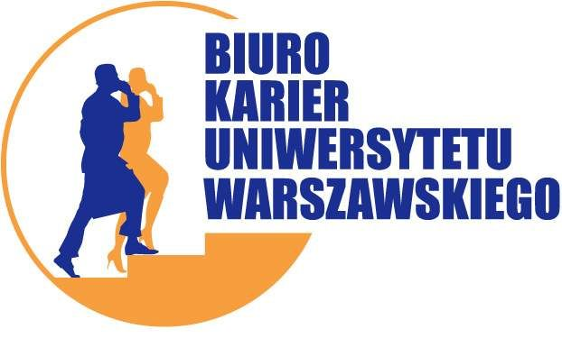 | www.biurokarier.uw.edu.pl | oferta ważna: 20-05-2019

